# Challenge 2: Tasks 5-9

### 5. List the absolute maximum and minimum stock value of each company.

*Input*: -

*Output*: for each company: company symbol, minimum stock value, maximum stock value

JSON Input Example: -

JSON Output Example :

{"solution": [

{"symbol":"BBY", "min":"0.5", "max":"72.95"},

{"symbol":"BBZ", "min":"0.7", "max":"70"}

]}

### 6. List all companies and months in which the average stock price (closing) was higher than X.

*Input*: integer X of the threshold

*Output*: each year and month, company symbol, average stock value

JSON Input Example:

{"threshold":"100"}

JSON Output Example :

{"solution": [

{"year":"2010", "month":"03", "symbol":"BBY", "average":"172.95"},

{"year":"2011", "month":"04", "symbol":"BBZ", "average":"273.95"}

]}

### 7. In financial applications a simple moving average (SMA) is the unweighted mean of the stock price (closing) of the previous N days(see graphics). Define the SMA of a company X.

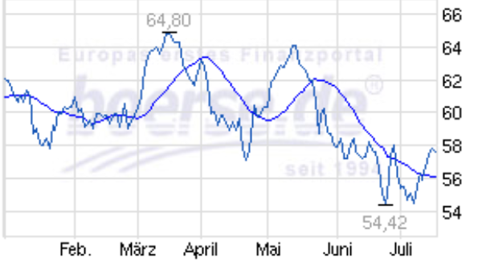

*Input*: String X of the company symbol,

the date for which the SMA should be calculated  
 integer N of the number of days

Output: the SMA for the given day

JSON Input Example:

{"symbol":"BBY", "date":"2013-04-14", "days":"3"}

JSON Output Example :

{"solution": [

{"sma":"31.7"}

]}

**8. Translate the average daily stock price of stock X into Euro for all trading days of a given year. (Assume that the rates table contains all the changes in the exchange rate that happened in Euro to Dollar). Average means the mean of all values of this day, no matter when they occurred.**

*Input*: The company symbol, the year

Output: the average daily stock value

JSON Input Example:

{"symbol":"BBY", "year":"2013"}

JSON Output Example :

{"solution": [

{"date":"2013-06-06", "averageeur":"172.95"},

{"date":"2013-06-06", "averageeur":"102.95"}]}

### 9. A weighted moving average (WMA) contains for each day and stock symbol a smoothed value. This value consists of the sum of weighted values (the sum of the weights is 1) of days in the past and future of a specific day, which is defined by a configurable mask. Calculate the WMA of a given symbol and mask.

*Input*: the symbol, year, and mask for smoothing (see example)

Output: for each day: the WMA and date­­­

JSON Input Example:

{"symbol":"BBY", "year":"2012",

"-1":"0.25", "0":"0.5", "1":"0.25"

}

Other possible masks:

"-2":"0.1", "-1":"0.15", "0":"0.5", "1":"0.15", "2":"0.1"

"-3":"0.25", "-2":"0.25", "-1":"0.25", "0":"0.25"

The first number in each pair signifies the day in relation to the current day. i.e. 0 is the current day, -1 is the day before, 1 is the next day, etc.

JSON Output Example :

{“solution”: [

{"date":"2012-01-01", "WMA":"70.5"},

{"date":"2012-01-02", "WMA":"71.0"},

…

]}